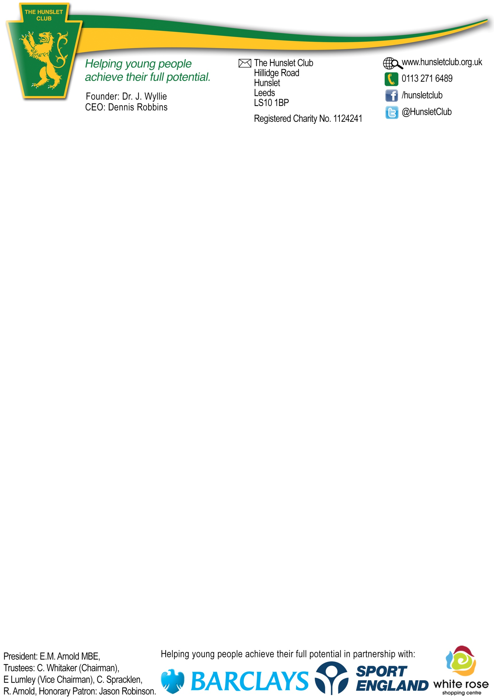

Company/Contact Name

Correspondence Address

Email address

Mobile Number

Team sponsoring

Single or double-sided banner
Single - £125.00
Double - £250.00

Please note that all logos/artwork that is to appear on the banner must be forwarded to ahaigh@hunsletclub.org.uk in high resolution format (preferably as an eps file)
All wording must be confirmed below including confirmation of any specific typestyle to be used. If no typestyle is stated a proof will be created using an appropriate typestyle

Wording on the banner (Century Gothic Bold Typeset)

Office Use only
Date proof sent to sponsor for approval
Date banner ordered – details added to spreadsheet
Date banner erected
Diarised for renewal
Confirmation letter to sponsor

Pitch-side Banners/Team Sponsorship

